**10. Write the following expression in a Java / Python / in your program**

**Exercise**

* **Write the following expression in a Java / Python / in your program   
  (v^2-u^2)/2as** 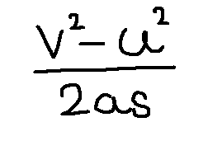

**Approach:**

**So here we did like this**

**Just do this**

**(v*v) - (u*u))/ (2*a*s)**

**Solution 👇**

**Java :**

**import java.util.Scanner;**

**public class CodeXam {**

**public static void main(String[] args) {**

**double v,u,a,s;**

**Scanner sc = new Scanner(System.in);**

**System.out.println("Equation is (v^2 -u^2)/(2as)");**

**System.out.println("Enter your value of v");**

**v = sc.nextInt();**

**System.out.println("Enter your value of u");**

**u = sc.nextInt();**

**System.out.println("Enter your value of a");**

**a = sc.nextInt();**

**System.out.println("Enter your value of s");**

**s = sc.nextInt();**

**double d = ((v*v) - (u*u))/ (2*a*s) ;**

**System.out.println("your result is "+d);**

**}}**

**output:**

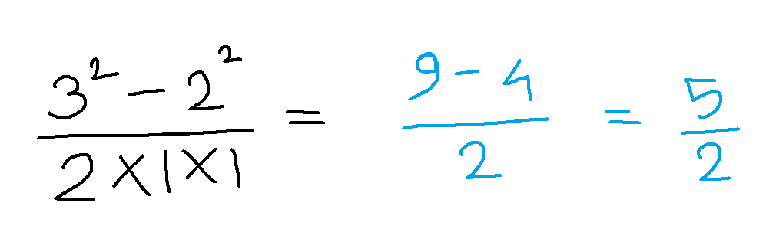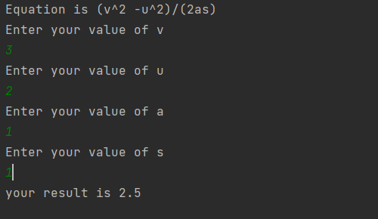

**Python :**

**print("\nEquation is (v^2 -u^2)/(2as)")**

**v = int(input("\nEnter the value of v: "))**

**u = int(input("Enter the value of u: "))**

**a = int(input("Enter the value of a: "))**

**s = int(input("Enter the value of s: "))**

**result = ((v*v) - (u*u))/ (2*a*s)**

**print("Your result is :", result)**

**output:**

